**SysOps Tools AWS (Amazon Web Services) Basics**

**Name: Lavish Sharma**

**Batch: 9**

Sprint - 1 (Assignment - 3)

**Task 1** - Create a Linux Instance connect it with SSH and via Putty as well.

**Task 2** - Create the Windows instance and login into it.

**TASK 1**

1. First, we need to login to our AWS Account and then open Management Console and search for EC2.

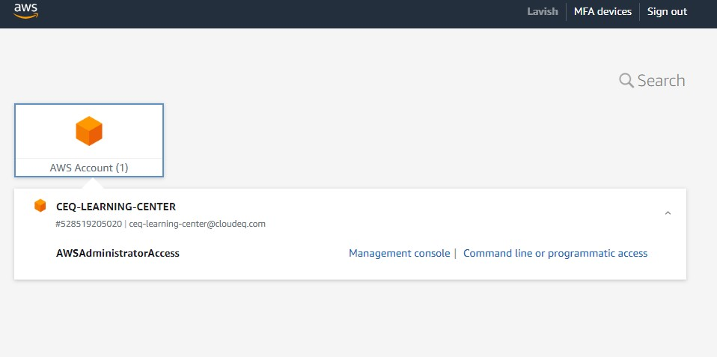

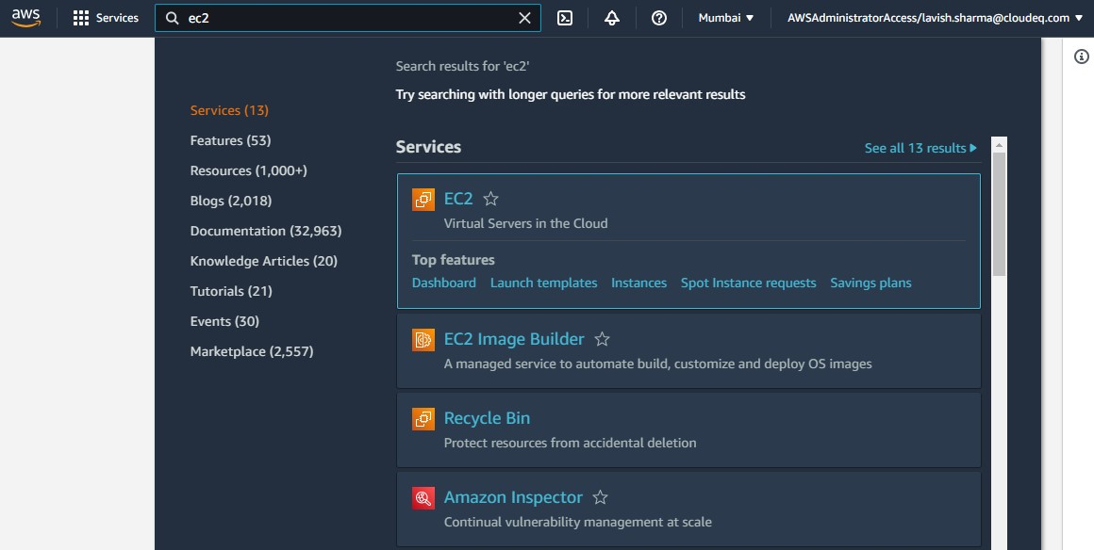

1. After opening EC2, click on **Launch Instance** button and provide details required like Name and Tags, Application and OS Images, etc..

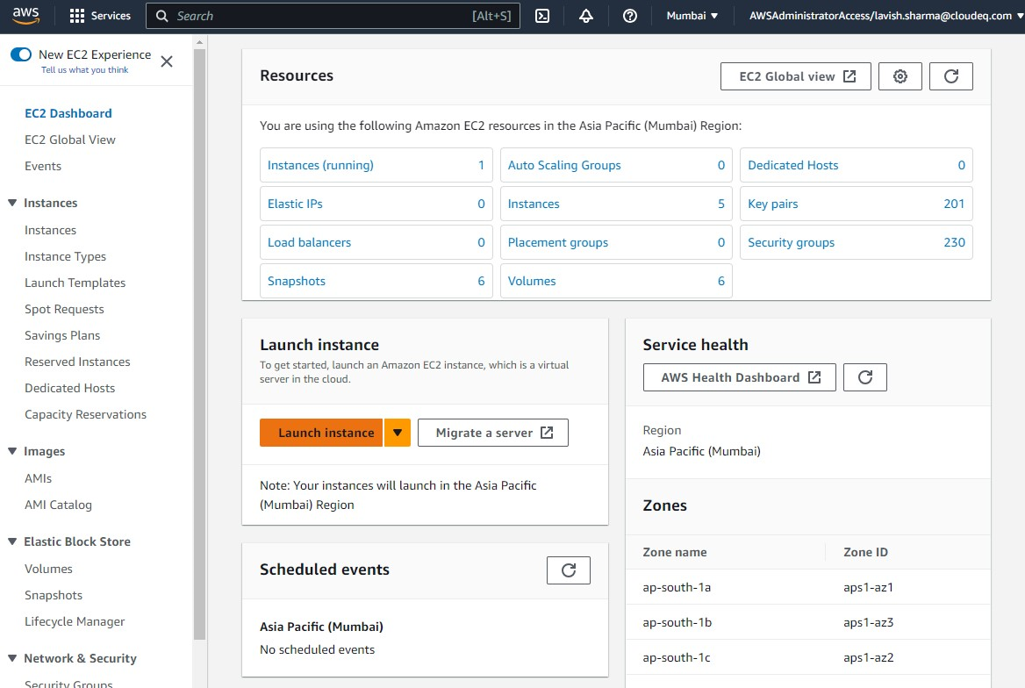

1. Now on Name and Tags section, we need to provide three keys, values and their resource types. We need to select Instances and Volumes as we are going to use them.

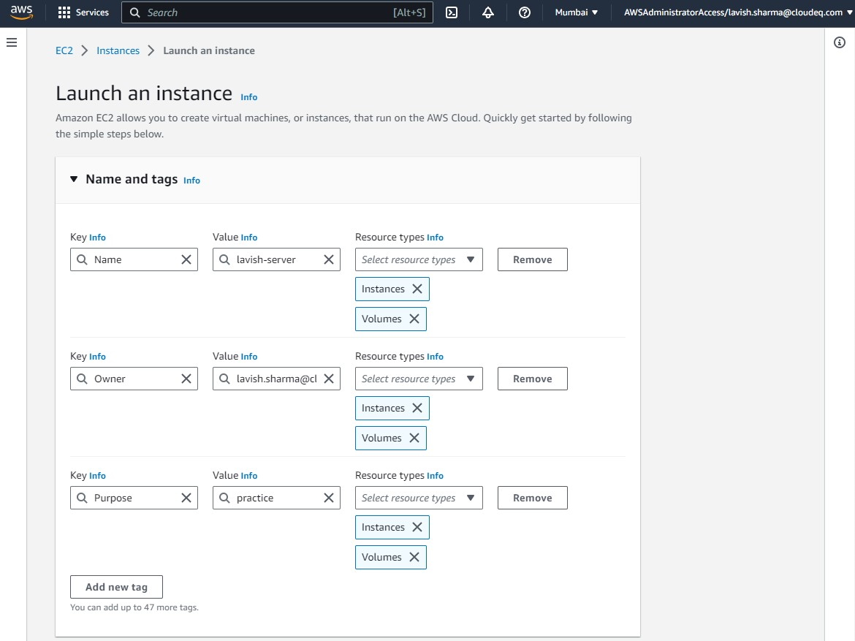

1. Now to create Amazon Linux Instance, select Amazon Linux under Application and OS Images (Amazon Machine Image) section.

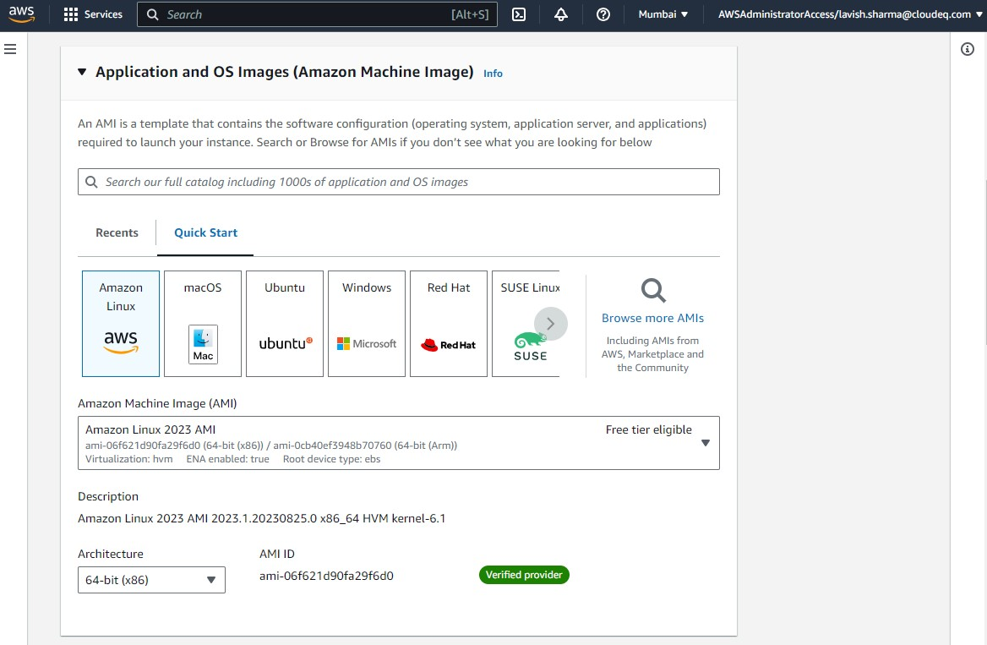

1. Now to securely connect to instance, we need to create a Key Pair. Click on the Create new key pair button and provide a name to it. After creating Key Pair select it as it should be downloaded to your system. In this case, “lavish-practice.pem”.

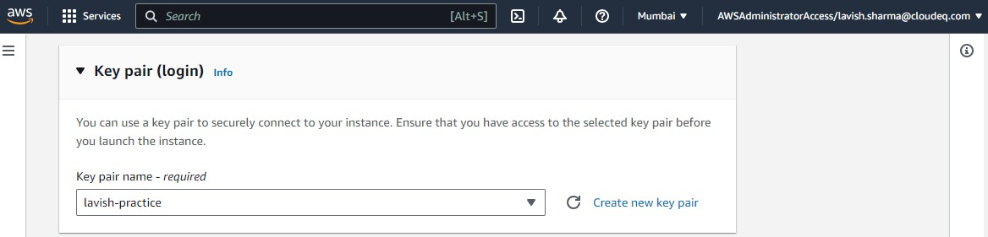

1. Now scroll down and click on Launch Instance and a new instance will be created.

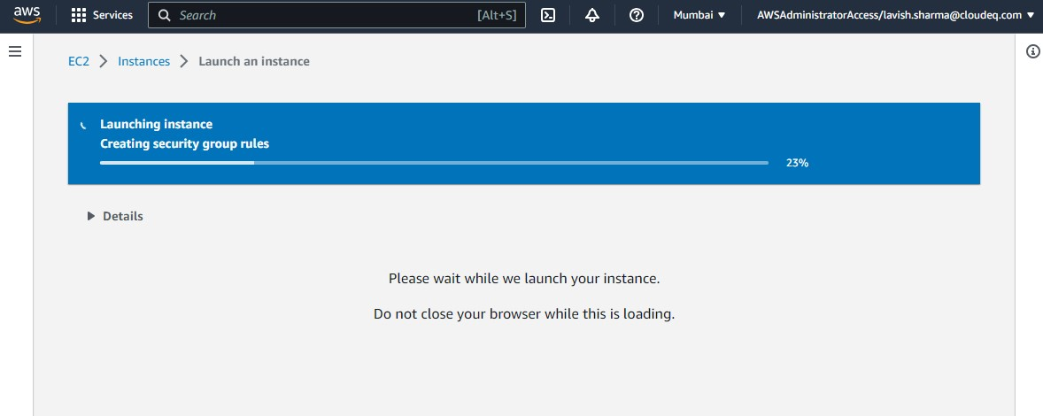

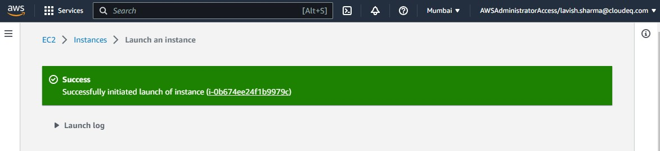

1. Now click on the ID of instance to open it. Select it and on the top of console click on Connect button.

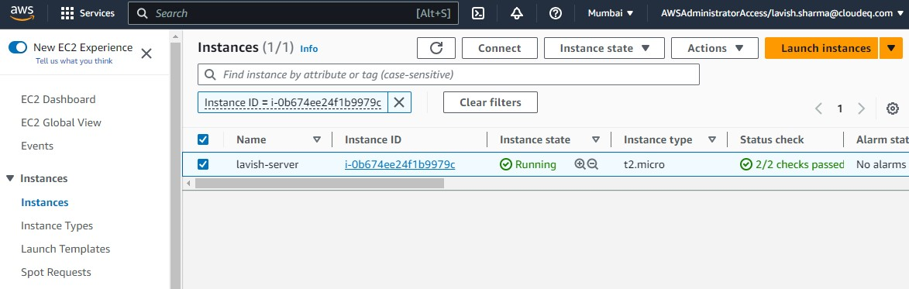

1. Now we have all things to connect to our instance through SSH client. Copy command written under Example.

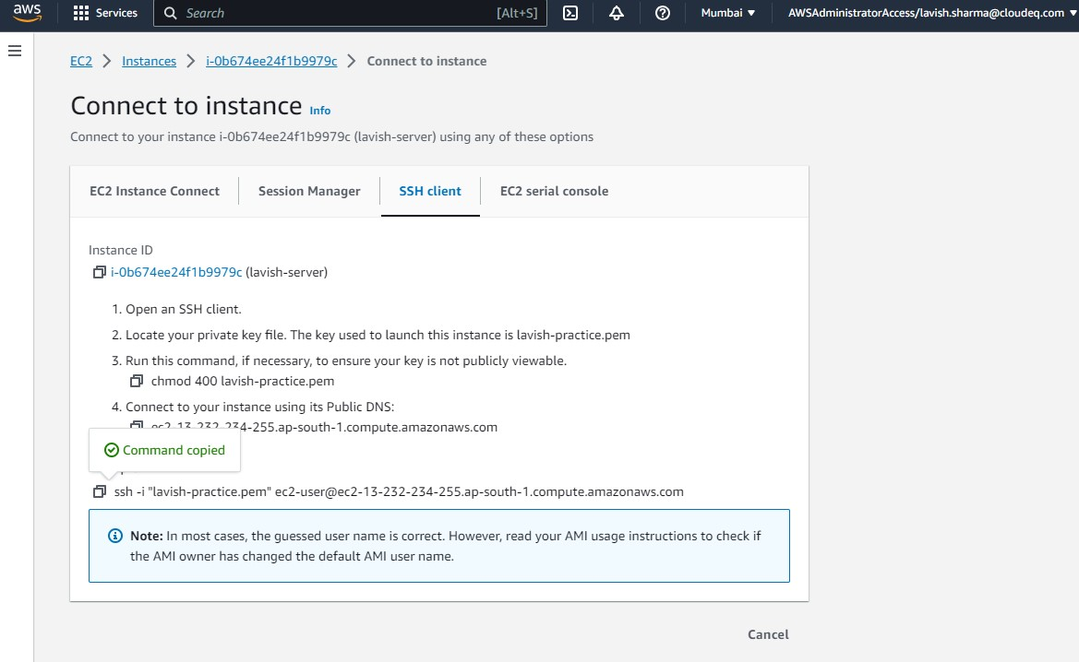

1. Now to connect SSH client with our Linux instance, first we need to locate Key Pair file that we have downloaded in previous step. Then open GitBash for that directory.
2. A new window of GitBash will open. Now to check that we are in a correct directory which should include .pem file, type command **ls**. It will give all the files and folders existing in the current working directory.
3. Now paste the command that we have copied in Step 8. It will ask for confirmation, type yes and hit enter. And now we are successfully connected SSH client with EC2 Linux Instance.

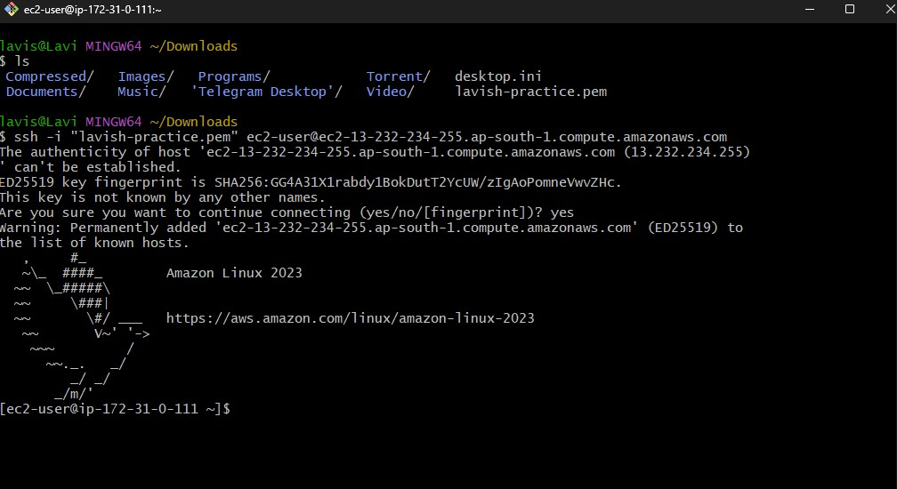

1. Now our second part is to connect the same instance through PuTTY. For that we need to dowload two things, PuTTY and PuTTY Key Generator from [www.putty.org](http://www.putty.org). After downloading both, install PuTTY.
2. Now to connect to PuTTY, we need key pair that we have downloaded previously but it does not support .pem file format. So, for that we need to convert it to .ppk by using PuTTY Key Generator.

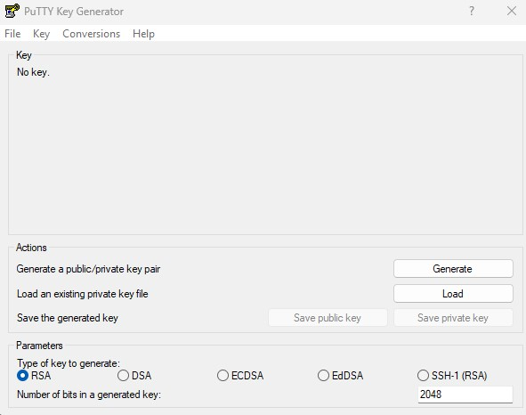

1. Click on Load button and select .pem file. And after that click on Save private key button to save converted file which is supported by PuTTY.

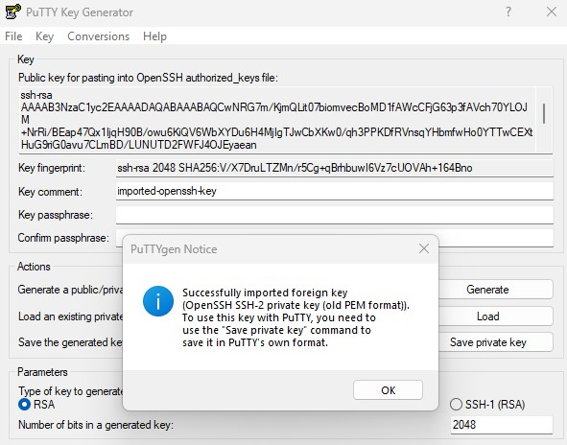

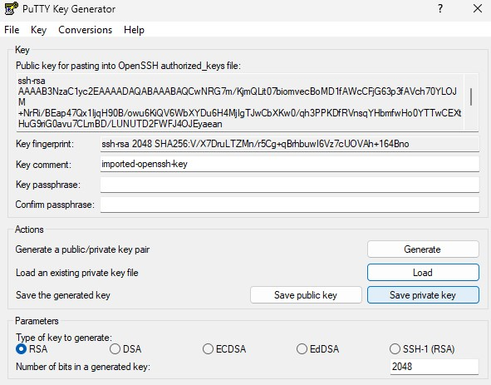

1. Now start PuTTY, copy command which is select in the image below as it is a Host Name which is required. And paste it in the Host Name (or IP address) section. And provide session name as well.

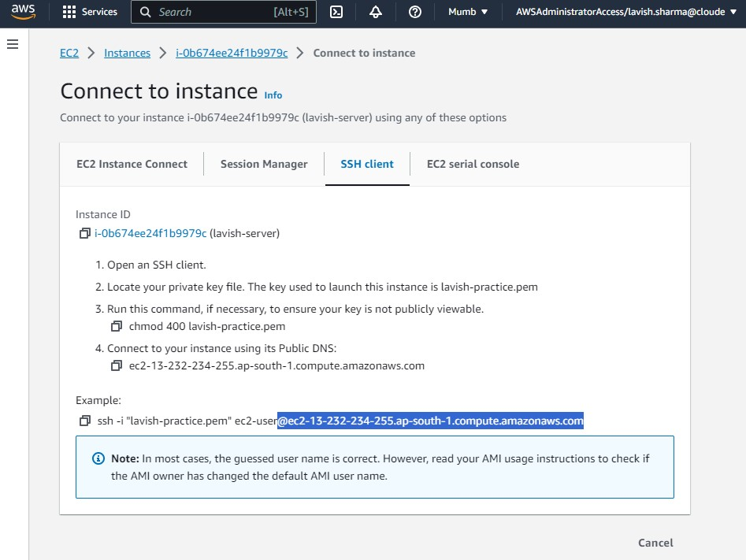

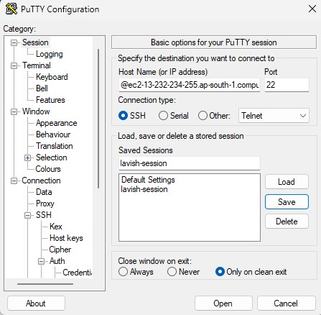

1. Now again copy command which is select in the image below for username. And paste it in Auto-Login Username section by navigating to Data under Connection.

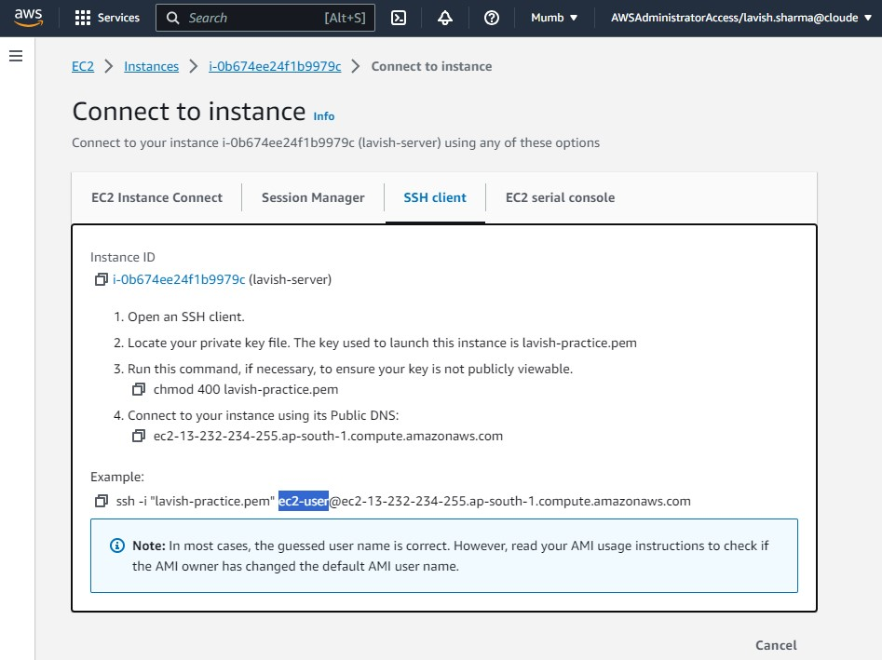

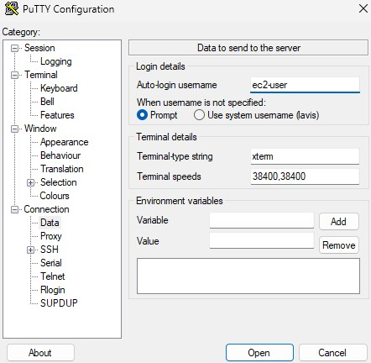

1. The third thing that we need to provide it, the converted key pair. For that navigate to Credentials under Auth which is in SSH and click on Browse button under Private key file for authentication. Select your converted key pair file in this case we have “converted-lavish-practice.ppk”.

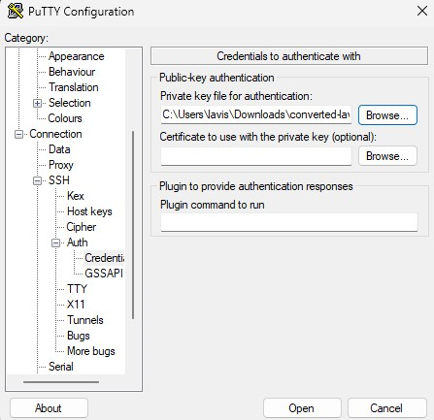

1. Now navigate to Session and select our session name. Now a new window will appear and it will ask for Login as, for this you need to provide username that we pasted in PuTTY before.

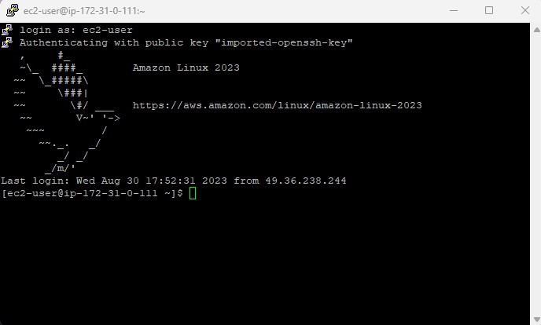

**TASK – 2**

1. Now for task 2, we need to create a window instance. For that launch new instance by click on Launch instance button.



1. Specify Name and Tags like Name, Owner and Purpose. Like we did in previous task.

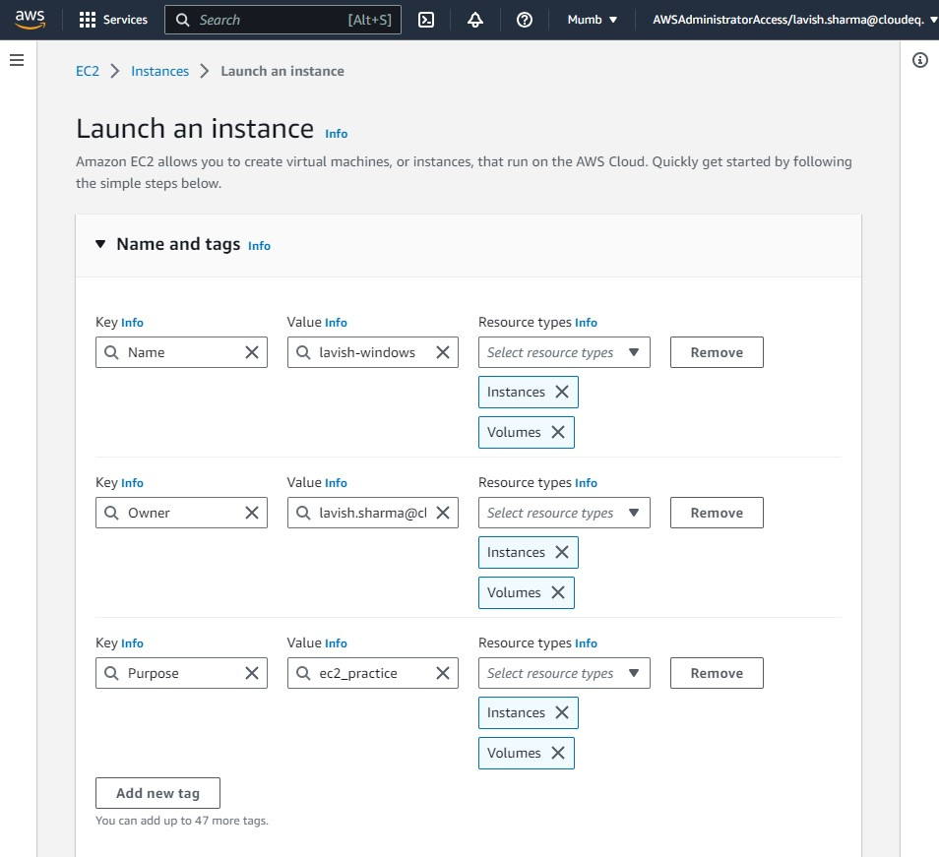

1. Now to create Amazon Windows Instance, select Amazon Windows under Application and OS Images (Amazon Machine Image) section. And select the previously created .pem file in Key Pair section. Scroll down and click launch instance.

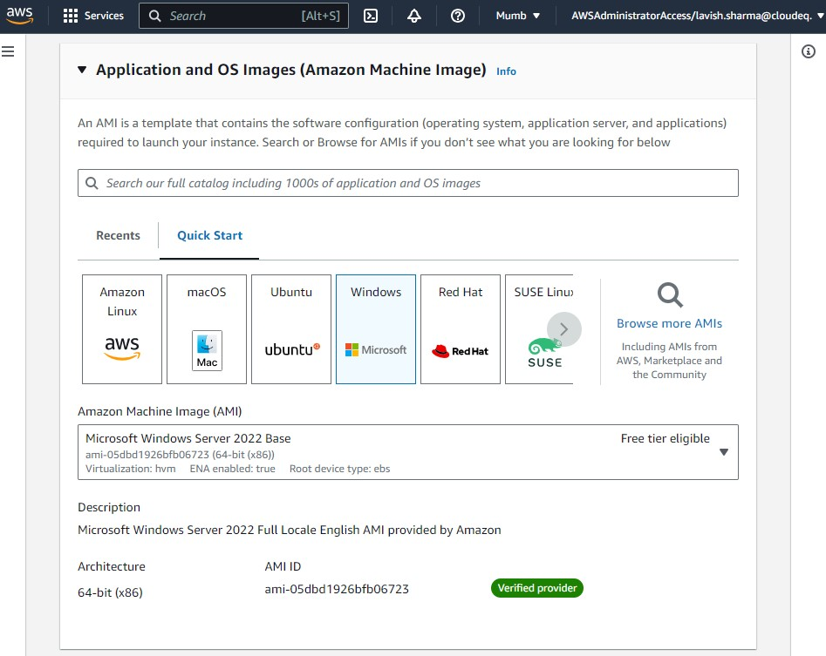

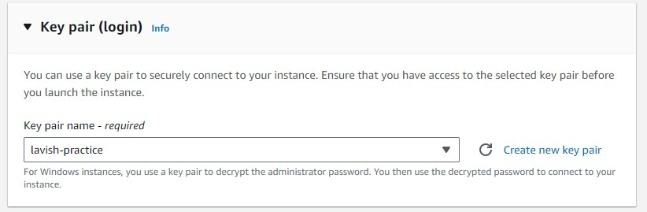

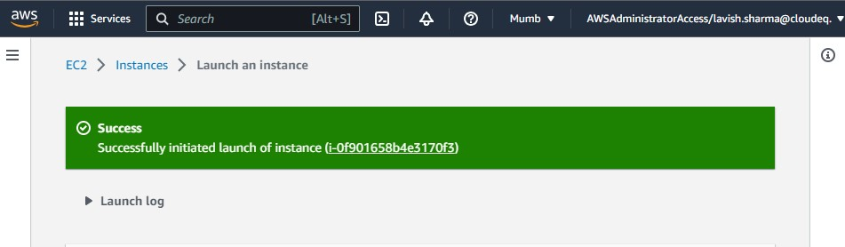

1. After launching of instance, we need to connect it. So select it and click on Connect button.

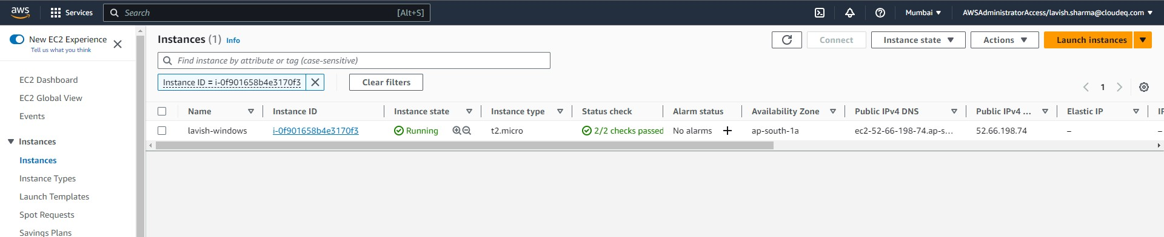

1. Now click on Get Password and select .pem file from your system. And click on Decrypt password.

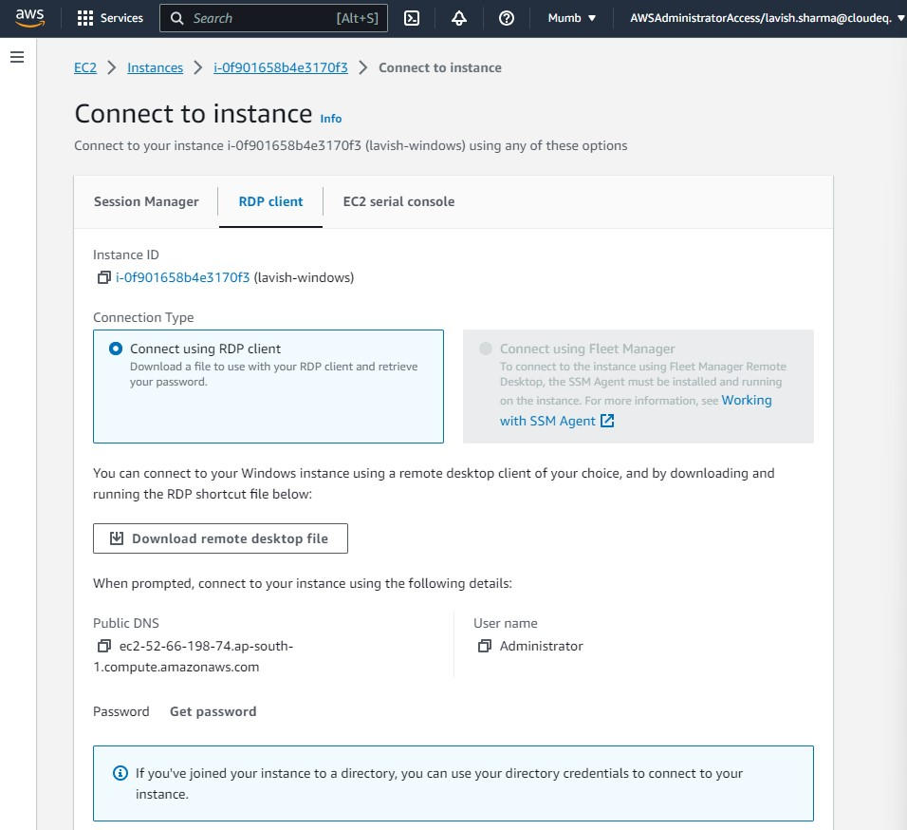

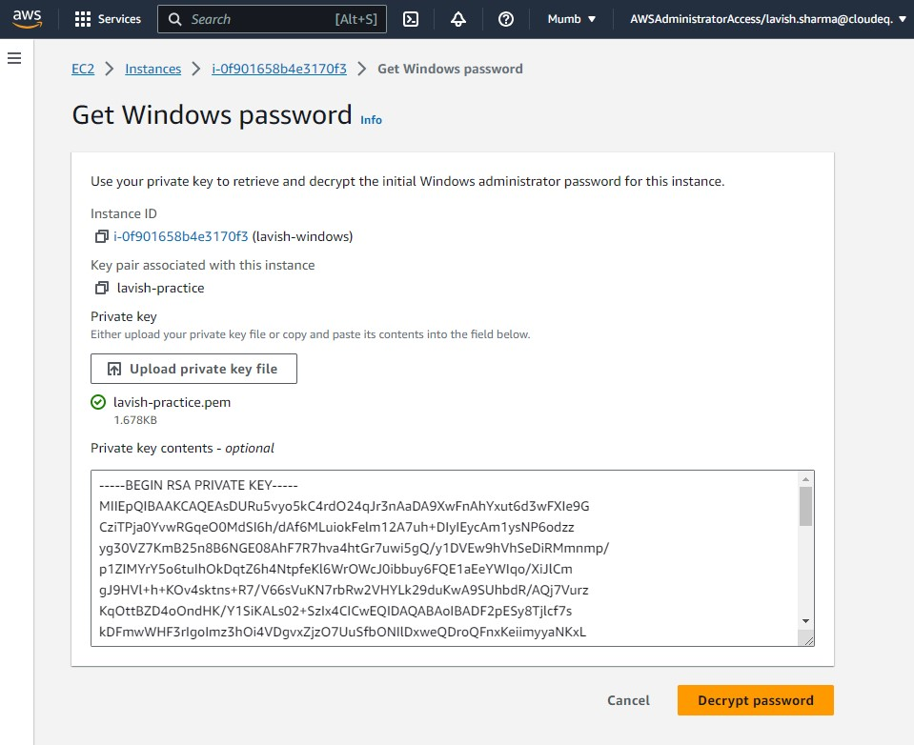

1. Copy decrypted password and click on Download remote desktop file.

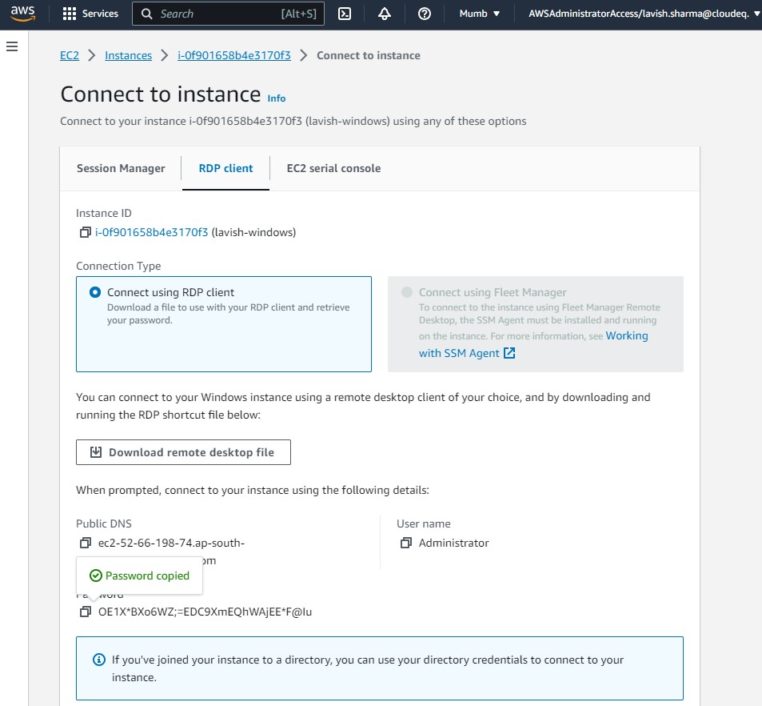

1. Open the downloaded file and click on connect. Paste copies password and hit enter. And after that click Yes button.

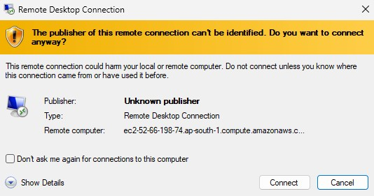

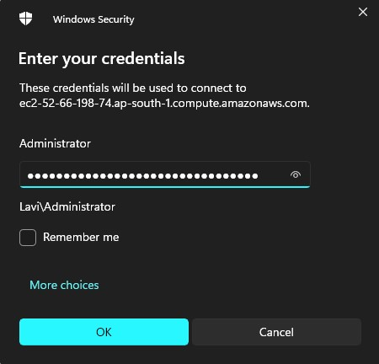

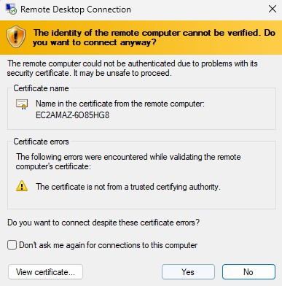

1. A new window will open, which is our windows instance. We have successfully connected to the EC2 windows instance.

